**Project Title:** Laptop Request – ServiceNow Project Documentation

**Team Id:NM2025TMID15022**

**Team Members:4**

Team Leader: KARTHIKA B

**Team Member 1 :** KARTHIKA S

**Team Member 2 :** MONISHA K

**Team Member 3:**SINDHUJA R

# Problem Statement

Employees often need laptops and accessories for their work. In many companies, these requests are made through emails or manual processes, which causes delays, mistakes, and no proper tracking.  
  
To solve this, we need a simple and structured Service Catalog Item in ServiceNow that allows employees to request laptops, give justifications, and add accessories only when needed.

# Objective

1. To design and configure a Service Catalog Item in ServiceNow for laptop requests.
2. To apply Catalog UI Policies that dynamically control field visibility and mandatory conditions.
3. To implement a UI Action (Reset Form) for user convenience.
4. To capture all configurations in a Local Update Set and export/import it between different instances.
5. To test and verify the catalog item functionality in the target instance.

# Skills Gained / Demonstrated

* ServiceNow Basics (navigation, update sets)
* Service Catalog Management (creating items, adding variables)
* UI Policy & Policy Actions (show/hide fields, mandatory rules)
* UI Actions & Client-Side Scripting (g_form methods in JavaScript)
* Update Set Migration (export/import changes)
* Testing & Validation (ensuring proper catalog item behavior)

# Implementation Steps

### Update set

## Step 1: Create Local Update Set

1. Open ServiceNow instance → All > Update Sets > Local Update Sets.  
   2. Click New → Enter name (e.g., Laptop Request).  
   3. Submit → Click Make Current (set active).

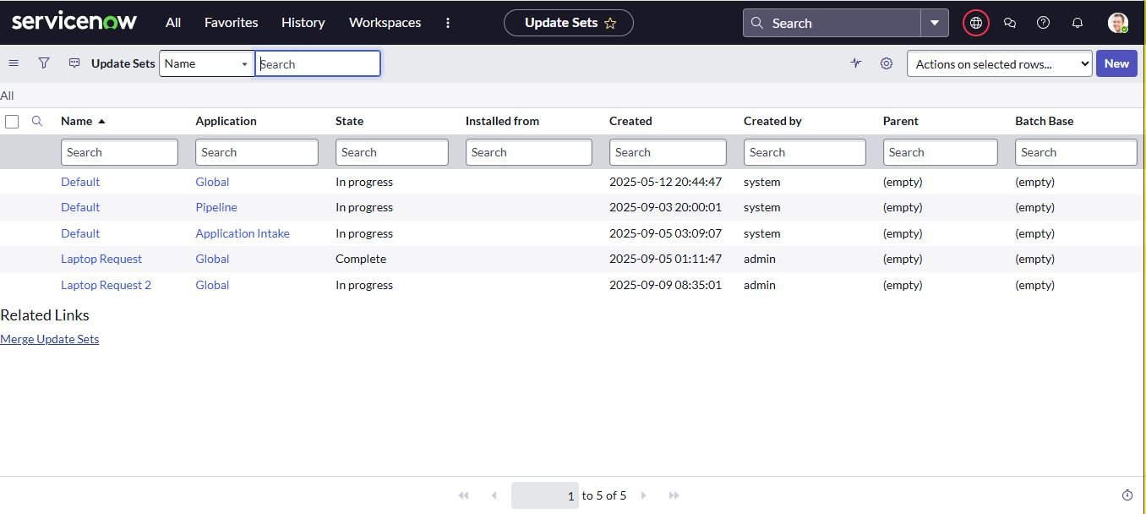

### Service Catalog Item

Step 2.1: Create Service Catalog Item

1.Navigate to Service Catalog > Maintain Items.  
2. Click New → Fill details (Name: Laptop Request).  
3. Save the item.

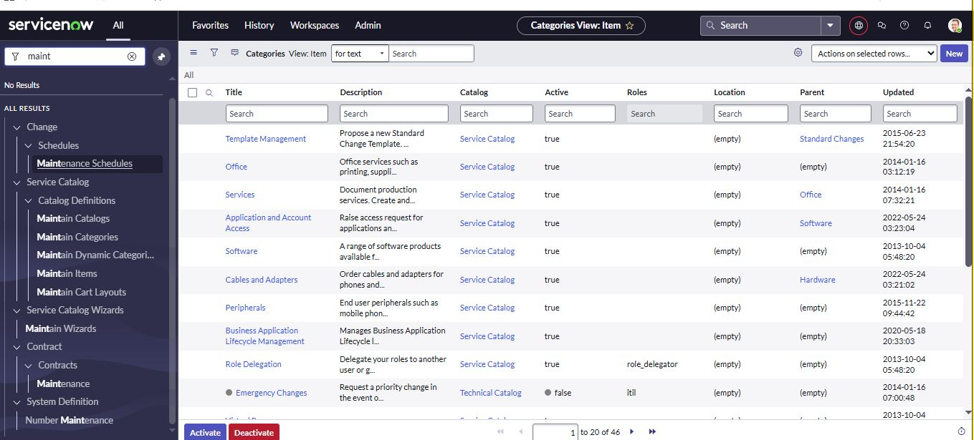

## Step 2.1: Add Variables

Add these one by one under Variables tab:

**Variable 1**

* Name: **Laptop Model**
* Type: **Single Line Text**
* Field Name: laptop_model
* Order: 100

**Variable 2**

* Name: **Justification**
* Type: **Multi Line Text**
* Field Name: justification
* Order: 200

**Variable 3**

* Name: **Additional Accessories**
* Type: **Checkbox**
* Field Name: additional_accessories
* Order: 300

**Variable 4**

* Name: **Accessories Details**
* Type: **Multi Line Text**
* Field Name: accessories_details
* Order: 400

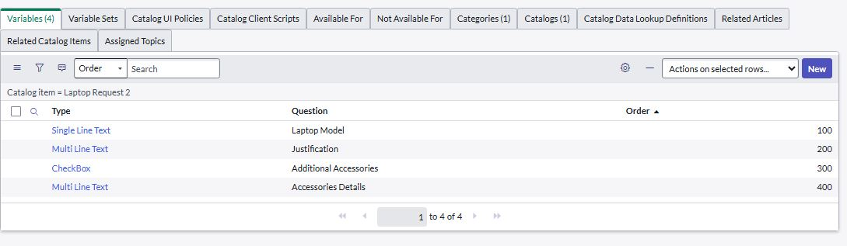

### UI Policy

## Step 3.1: Create Catalog UI Policy

1. - Go to **All > Service Catalog**.
2. Click **Maintain Items** under **Catalog Definition**.
3. Search and open **Laptop Request**.
4. Scroll down and click **Catalog UI Policies**.
5. Click **New**.
6. Enter **Short Description**: Show accessories details.
7. In **When to Apply**, set:
   * Field: additional_accessories
   * Operator: is
   * Value: true
8. Click **Save** (don’t submit).

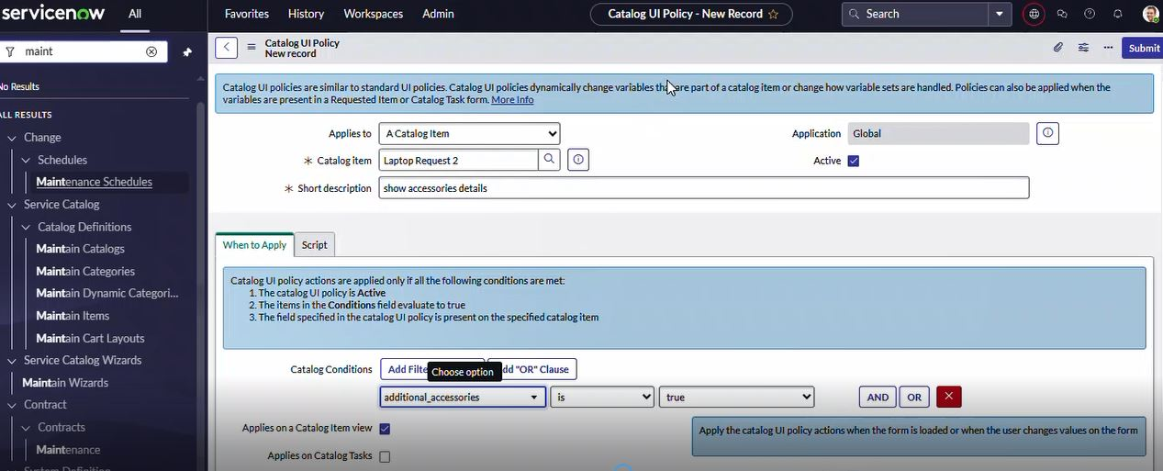

1. Scroll down and click **Catalog UI Policy Actions**.
2. Click **New**.
3. Set:
   * Variable: accessories_details
   * Order: 100
   * Mandatory: True
   * Visible: True
4. Click **Save**, then click **Save** again on the UI Policy form.

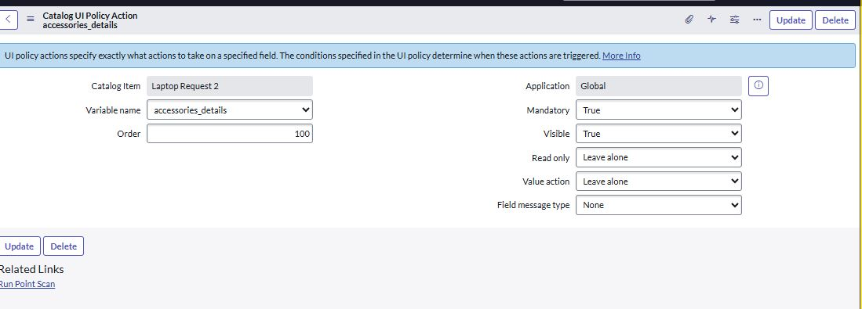

### UI Action

### Create ui action

1. Open **ServiceNow**.
2. Click **All**, then search for **UI Actions**.
3. Select **UI Actions** under **System Definition**.
4. Click **New**.
5. Fill in the details:
   * **Table**: shopping_cart (sc_cart)
   * **Order**: 100
   * **Action Name**: Reset form
   * Check **Client** (make it client-side).
6. In the **Script** box, paste this code:
7. function resetForm() {
8. g_form.clearForm();
9. alert("The form has been reset.");
10. }
11. Click **Save**.

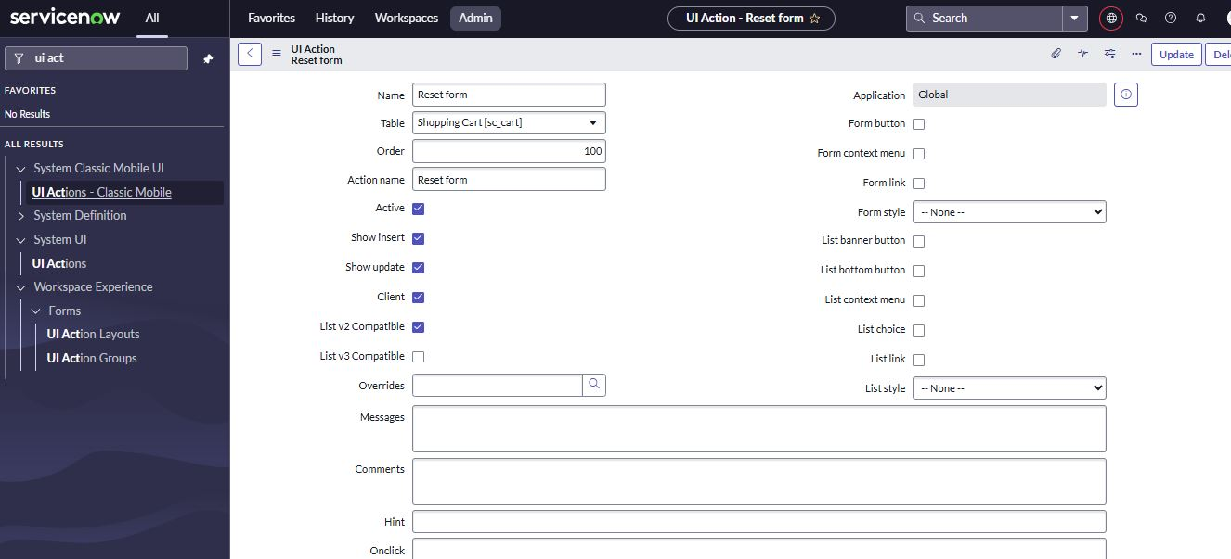

### Export Update set

## Export Update Set

1. 1. Click **All**, then search for **Update Sets**.
2. Select **Local Update Sets**.
3. Find and open the update set named **Laptop Request Project**.
4. Change the **State** to **Complete**.
5. Scroll down to the **Updates** related list to see the changes included.
6. Click **Export to XML** to download the update set file.

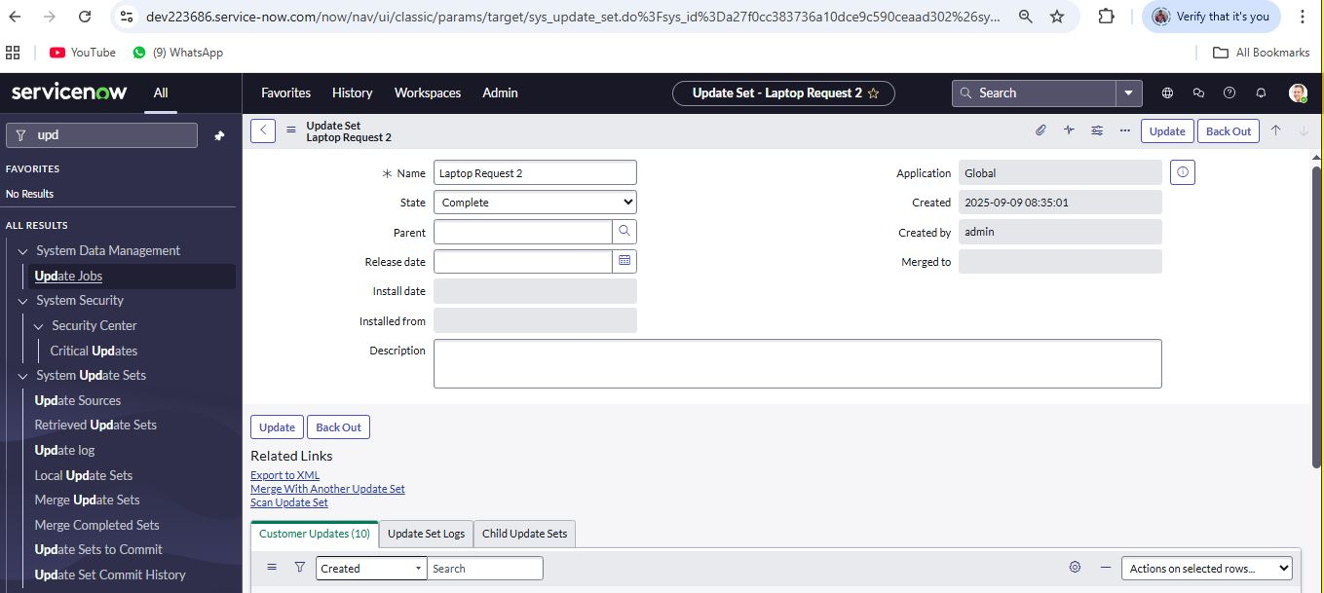

### Login to another Instance

## Import into Another Instance

1. Open an incognito window and log in to the other ServiceNow instance.
2. Click **All** and search for **Update Sets**
3. Click **Retrieved Update Sets**.
4. Scroll down and click **Import Update Set from XML**.
5. Upload the XML file you saved earlier.

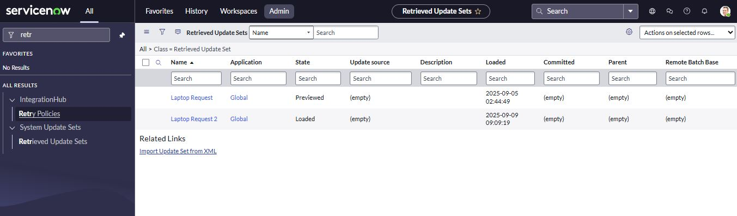

### Testing

### Testing

1. Open Service Catalog > Catalog > Hardware.  
2. Search for Laptop Request.  
3. Check:  
 - 3 variables show by default.  
 - If Additional Accessories is checked → Accessories Details field appears and is mandatory

### Conclusion :

The Laptop Request Catalog Item project highlights how ServiceNow’s Service Catalog can simplify and modernize the laptop request process within the organization. By introducing a dynamic and intuitive catalog item, the initiative minimizes errors, accelerates fulfillment, and ensures a seamless user experience. This transformation demonstrates the power of automation in replacing manual, error-prone practices with streamlined, efficient, and user-centric solutions. Ultimately, the project not only enhances IT service delivery but also boosts employee satisfaction by offering a modern and hassle-free request journey.